Creating a bucket in GCP and uploading HTML file:

Step 1: Once you are on the console, click on Storage under STORAGE on the left menu. Click on Browse from the drop down menu

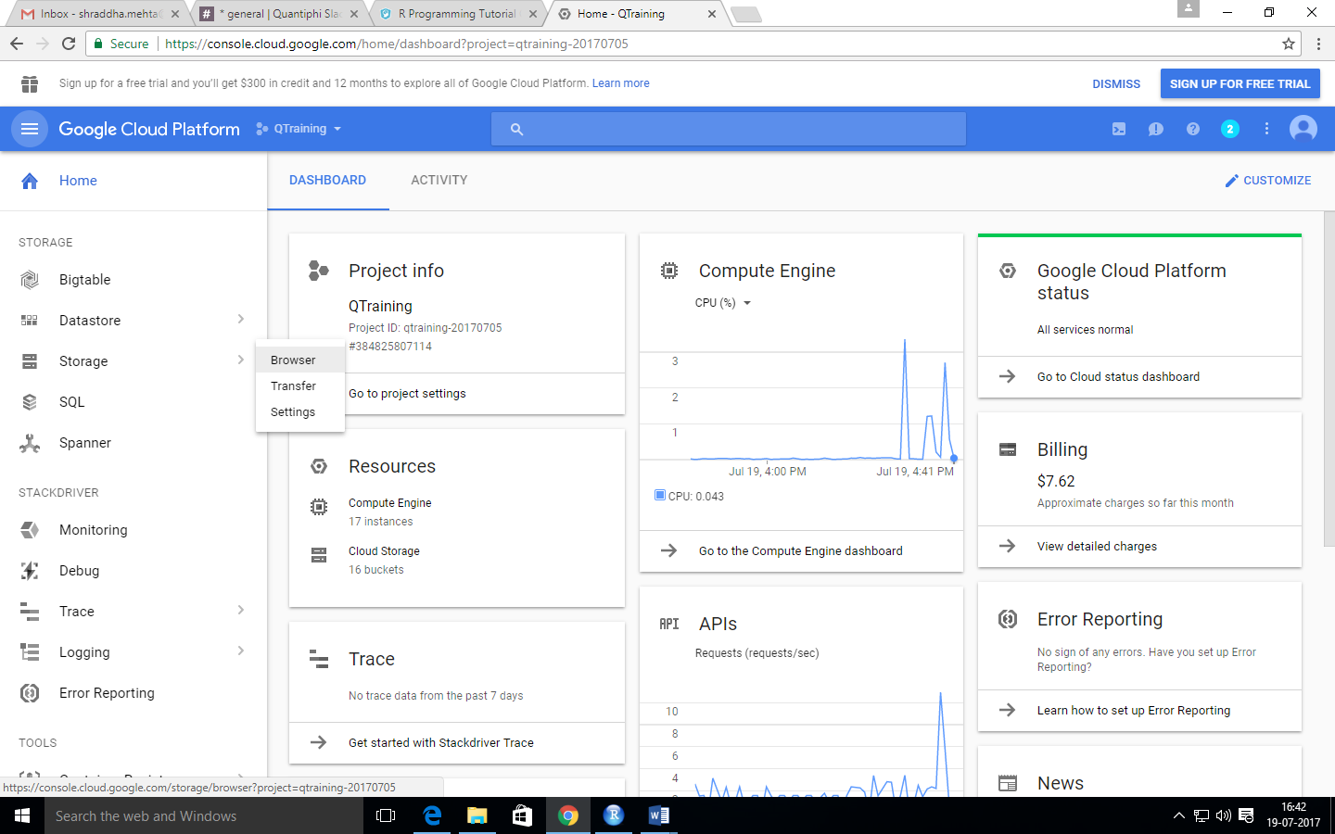

Step 2: Click on CREATE BUCKET on the top

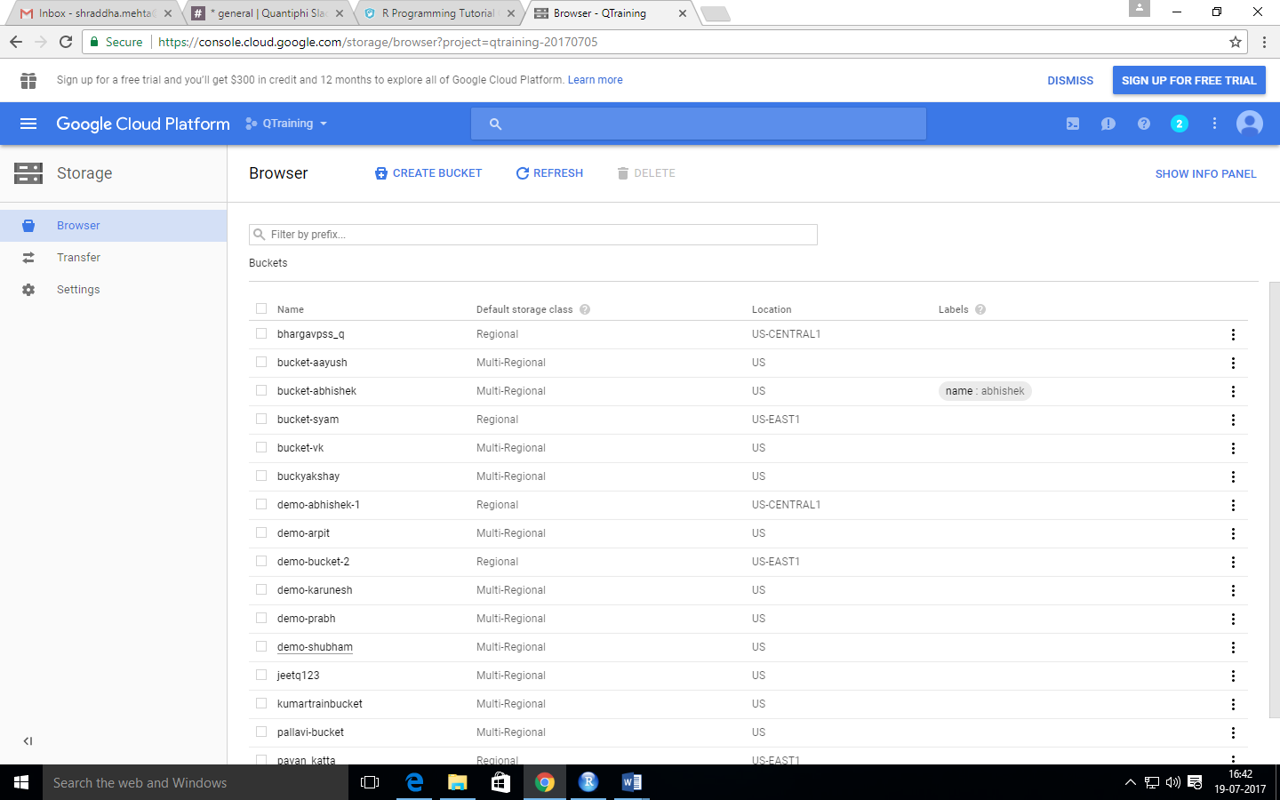

Step 3: After specifying relevant labels, click on Create at the bottom

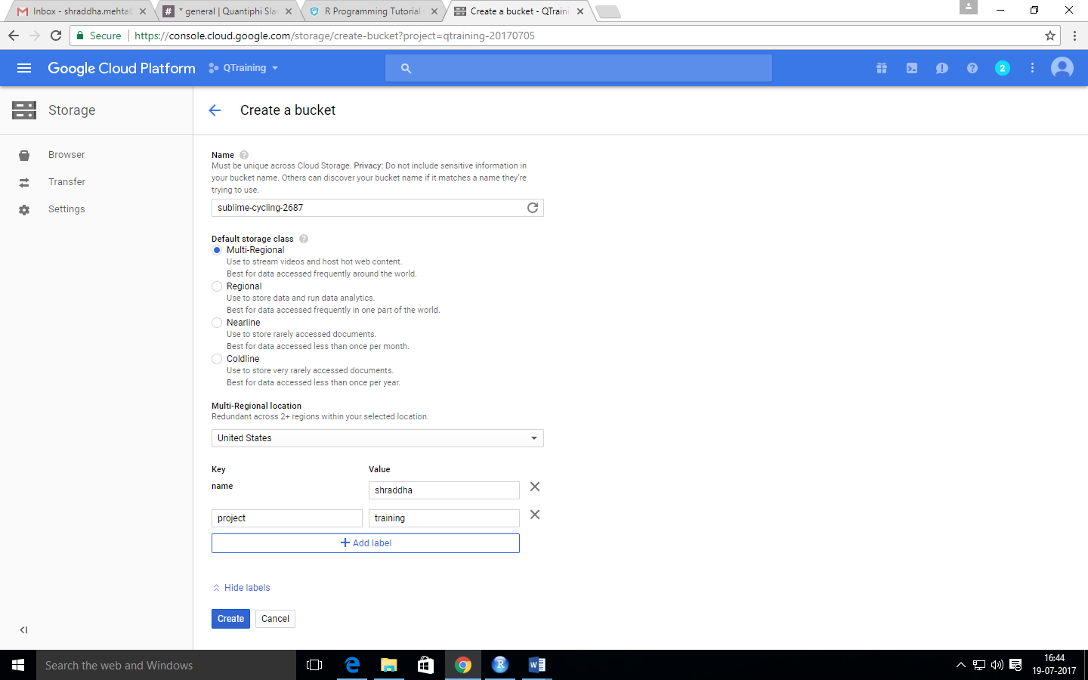

Step 4: Once the bucket is created, click on the UPLOAD FILES button on the top

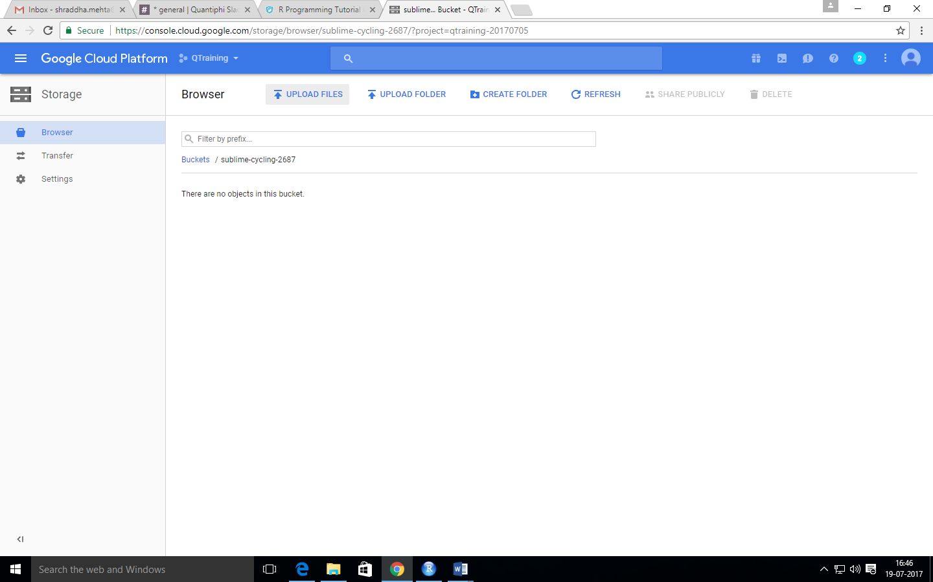

Step 5: Upload the file and make it publicly available by checking the tick box below Share publicly

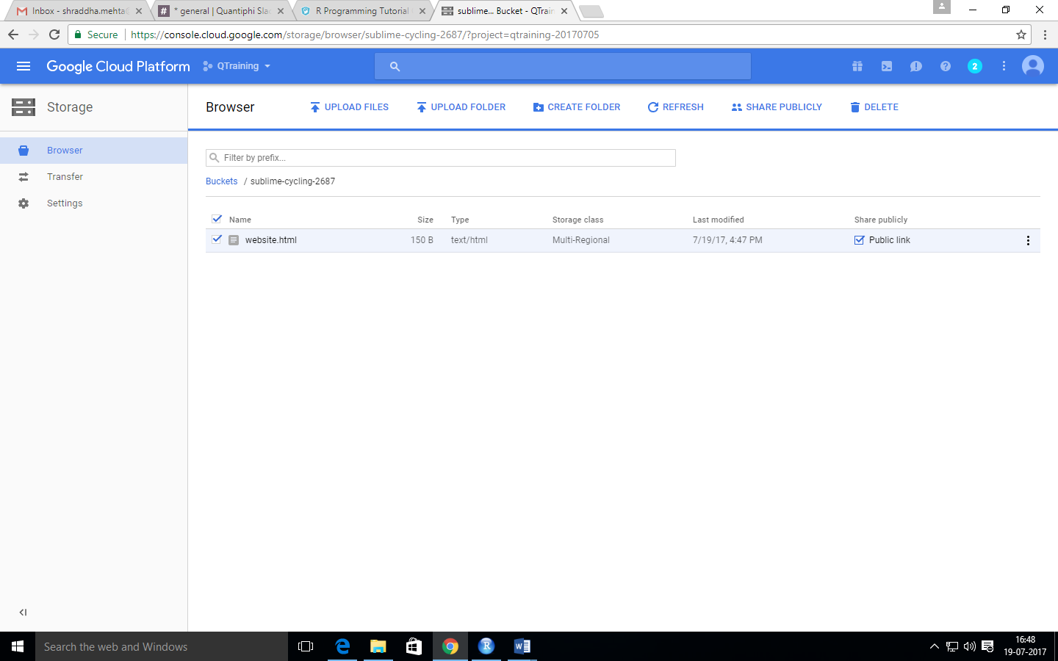

Step 6: Launch the website by clicking on the file or on the public link

